

PHYSICAL PLANNING AND DEVELOPMENT DEPARTMENT
MANDATES AND FUNCTIONS
2025

MANDATE
The core mandate of this service Unit is primarily to support the activities of the Commission under the direct coordination of the Executive Secretary to achieve the mandate of the commission.
The mandate of NSSEC is to monitor and evaluate the development of Senior Secondary Education in Nigeria with a focus on academic brief and Master plan implementation, staff support, infrastructural input and other issues pertinent to ensure quality senior secondary education in Nigeria.
To this end, the mandate of the Physical Planning Unit is to ensure the proper and efficient planning, development and maintenance of infrastructure that supports and enhances the development of senior secondary education in Nigeria.
The Physical Planning Unit by virtue of this, has the responsibility of:
- Infrastructure development: designing and developing infrastructure that supports senior secondary. education, including classrooms. Laboratories, libraries, administrative buildings, hostels, sports facilities and other requisite infrastructure.

- School facilities planning: Ensuring that schools have appropriate facilities to enhance learning.
- Spatial planning: Making sure that educational facilities are optimally located taking into account accessibility, safety, and environmental considerations.

- Monitoring and evaluation: Monitoring the development of physical infrastructure in senior secondary schools to ensure compliance with standards. This includes evaluating the adequacy, safety, and sustainability of school buildings and facilities.
- Regulatory compliance: Ensuring that physical development plans and projects conform to national building codes, environmental laws, and other regulatory frameworks relevant to educational institutions.
- Budgeting and resource allocation: Assisting in the budgeting process for physical infrastructure development and ensuring that resources are allocated for the construction and maintenance of senior secondary schools.

MISSION
To ensure professionalism in efficient and effective strategic planning, design, development and maintenance of all Physical infrastructure in Senior Secondary schools in Nigeria to support quality education, safety and accessibility in compliance with the set standards and specifications.
VISION
To create a modern, sustainable, and well developed infrastructure that supports and enhances the quality of senior secondary education in Nigeria.

The Physical Planning Unit aims to ensure that physical infrastructure plays a key role in improving the educational experience, contributing to academic success, and helping to achieve optimal learning environment for both the learners and educators.

STRUCTURE

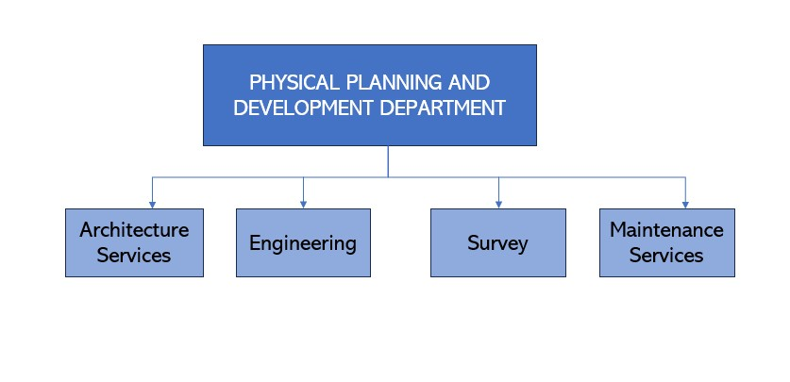
FUNCTIONS

- Assist in the establishment of Minimum Standards for Senior Secondary Education infrastructure.
- Assist in the preparation of guidelines for accessing, disbursement and utilization of the NSSEC Fund and other grants.
- Carry out market surveys for basic construction materials with a view to updating cost norms/ benchmark for FCTSEB and SSSEBs.
- Assess and vet SSSEBs Action plans for accessing FGN-NSSEC Grants and Intervention funds as it relates to Physical infrastructure and monitor compliance as required.
- Supervise direct intervention and constituency physical projects through the residency supervision arrangement and certification.
- Develop briefs and coordinate the activities of consultants engaged by the Commission for different projects. Advise on costs and execution methods.
- Assist in the preparation of NSSEC short-, medium- and long-term budgets for physical infrastructure interventions for the Commission.
- Plan, implement and monitor NSSEC/ Intervention physical projects with the aim of setting minimum standards for Senior Secondary Schools.
- Develop and maintain a digital database of all NSSEC physical intervention projects.
- Coordinate NSSEC physical development projects from conceptualization, design/ costing to supervision, completion, handover and maintenance of same through life cycle projects to ensure a conducive working environment for the users;
- Prepare periodic reports on all the physical development projects of the Commission.
- Concept design and appraisal of projects for the Commission’s intervention programmes.
- Maintain NSSEC buildings, furniture and facilities when the need arises.
- Prepare weekly, monthly and annual maintenance plans for all facilities.
- Advise the States on maintenance plan for their infrastructure facilities
- Provide technical expertise, support, assessment and implementation for establishing NSSEC Zonal offices in collaboration with other relevant Departments of NSSEC.
- Advise the Commission in collaboration with relevant Departments on the training and capacity building of the Professional and Technical staff in the Department.
- Perform any other functions as may be assigned from time to time.

ARCHITECTURE DIVISION
- Coordinate the concept design, and ensuring that all minimum standards for Senior Secondary school facilities are complied with.
- Assist in the preparation and updating of Minimum Standards for all infrastructural development in Senior Secondary Schools.
- Develop innovative designs in line with Minimum Standards for Senior Secondary Schools facilities. e.g., Classrooms, hostels, laboratories, workshops, sporting and other support facilities.
- Preparation and coordination of designs to include full working drawings with specifications, and tender documents for physical infrastructure projects.
- Supervise all physical development projects of the Commission as well as prepare and issue project Interim certificates and Certificates of Practical Completion.
- Assess and vet physical infrastructure components of FCT and State Senior Secondary Education Boards in preparation for relevant intervention and supervise direct intervention, zonal and constituency projects through residency supervision arrangements.
- Planning and coordination of condition survey of facilities and infrastructure to assess the physical condition and recommend for rehabilitation, upgrading or total replacement for budgeting and funding with relevant divisions.
- Design and supervision of the Construction/ renovation of NSSEC Zonal offices as required.
- Develop briefs for Consultant’s engaged by NSSEC for various physical infrastructure projects.
- Perform any other functions as may be assigned from time to time

ENGINEERING AND SURVEY DIVISION
- Assist in the preparation and updating of Minimum Standards for all Engineering components as it relates to infrastructural development in Senior Secondary Schools
- Engineering design and supervision of the Construction/ renovation of NSSEC Zonal offices as required.
- Assess and vet the engineering aspects of physical infrastructure components of State Senior Secondary Education Boards in preparation for relevant intervention.
- Supervise direct intervention and constituency projects through residency supervision arrangements.
- Assist in the conduct of conditional survey of facilities and infrastructure to assess the physical condition and recommend for rehabilitation, upgrading or total replacement for budgeting and funding.
- Carry out valuation based on progress reports as prepared by the Architect.
- Preparation of estimates, costs, bill of quantities for all Physical Development projects;
- Carry out perimeter survey of sites where intervention is required.
- Advise on the repair of equipment when required.
- Perform any other functions as may be assigned from time to time

MAINTENANCE DIVISION
- Carry out maintenance of NSSEC buildings and facilities as required.
- Prepare weekly, monthly and annual maintenance plans for all facilities.
- Collaborate with relevant Departments and Units to ensure effective working operations of facilities.
- Establish and maintain a workshop to handle routine repairs.
- Advise on appropriate Life cycle cost advantages.
- Maintain schedules, logs and records of the maintenance of NSSEC facilities.
- Assist in the conduct of condition survey of facilities and infrastructure to assess the physical condition and recommend for rehabilitation, upgrading or total replacement for budgeting and funding.
- Ensure resource optimization in the maintenance of NSSEC facilities such as Power Plants, Air Conditioners, technical equipment and other facilities.
Perform any other functions as may be assigned from time to time

Arc. Maimuna Umar, FNIA
Deputy Director/ Head Physical Planning Unit
26th NOVEMBER, 2025

